**Project Design Phase-II**

**Data Flow Diagram & User Stories**

|  |  |
| --- | --- |
| Date | 03 October 2022 |
| Team ID | PNT2022TMID43957 |
| Project Name | PLASMA DONOR APPLICATION |
| Maximum Marks | 4 Marks |

**Data Flow Diagrams:**

**Plasma Donor Application Data Floe Digram**

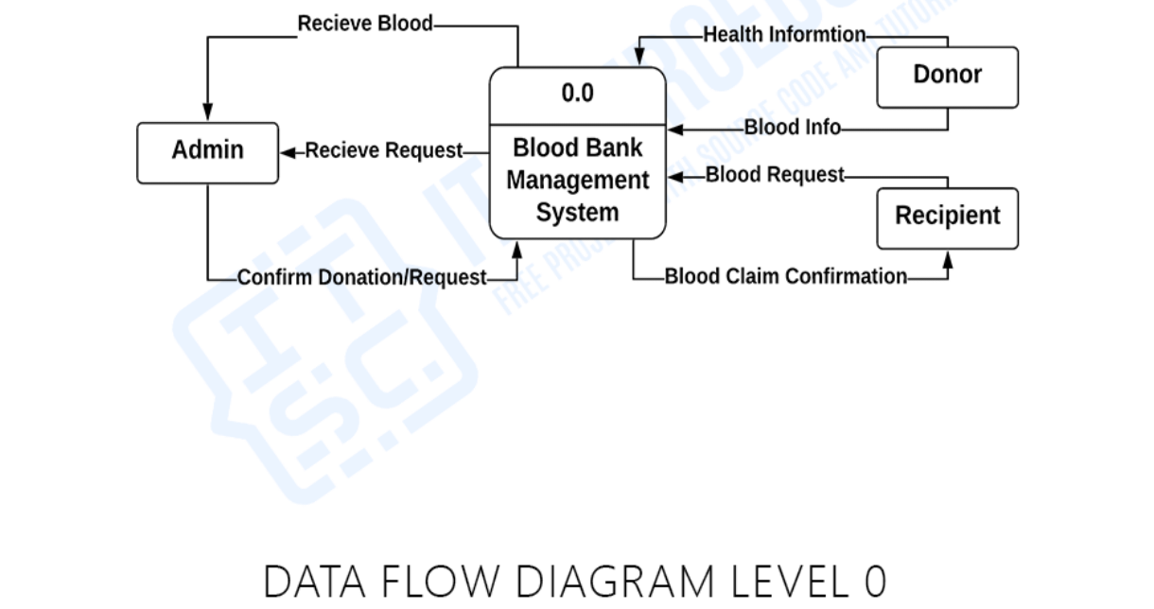

**Plasma bank**

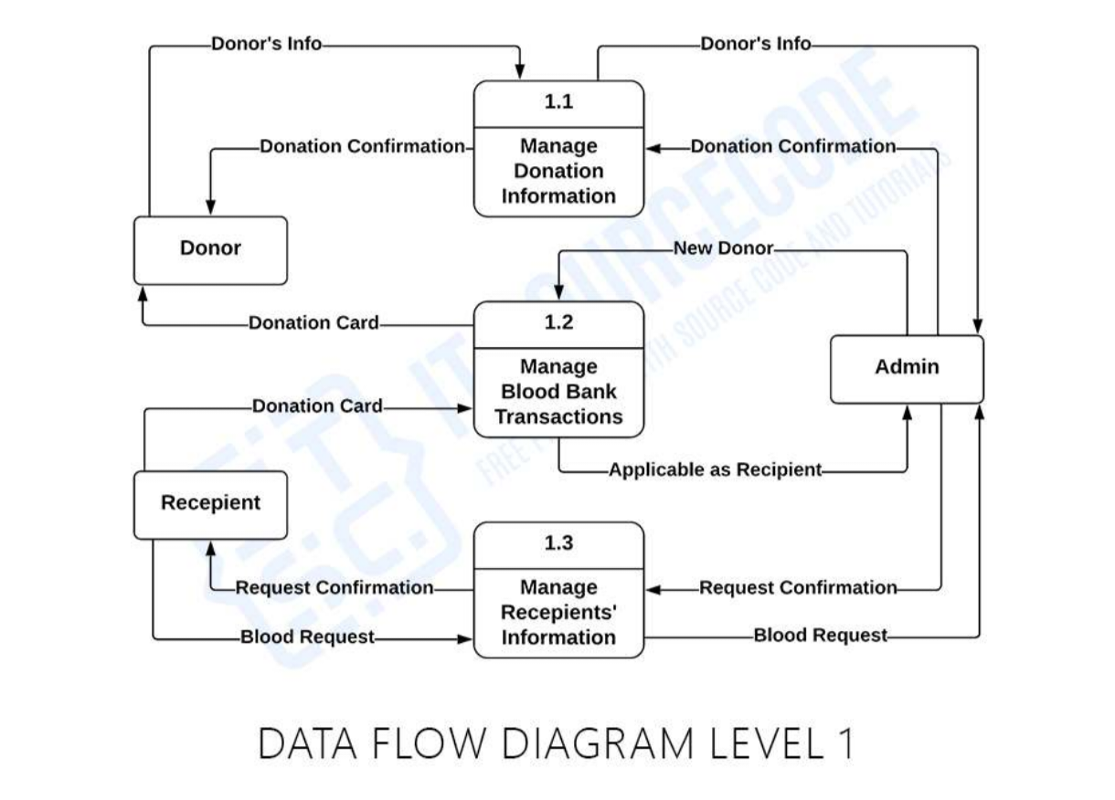

**Plasma Bank**

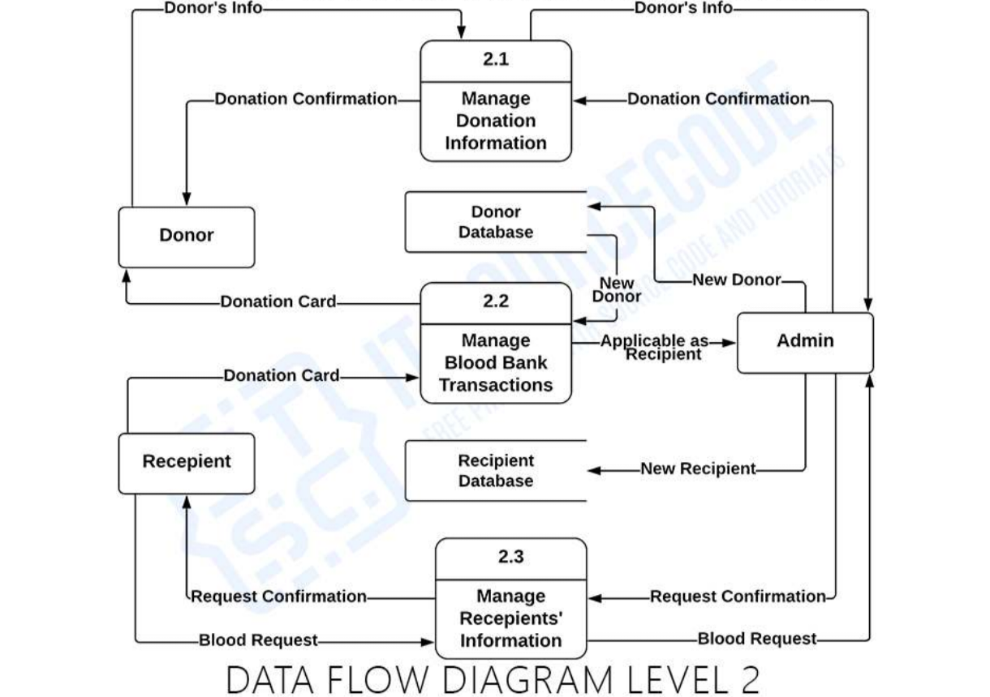

**Plasma Bank**

**User Stories**

Use the below template to list all the user stories for the product.

| **User Type** | **Functional Requirement (Epic)** | **User Story Number** | **User Story / Task** | **Acceptance criteria** | **Priority** | **Release** |
| --- | --- | --- | --- | --- | --- | --- |
| Donor | App Registration | USN-1 | As a user, I can register for the application by entering my email, password, and confirming my password. | I can access my account / dashboard | High | Sprint-1 |
|  | Login | USN-2 | As a user, I can log into the application by entering email & password | I can receive confirmation email & click confirm | High | Sprint-2 |
|  | Register For Donate | USN-3 | As a user, I can log into the application and find the current bank to donate plasma and confirm my booking | I can register & access the dashboard with Facebook Login | Medium | Sprint-3 |
| patient/doctor | Find the bank | USN-4 | As a patient, I can directly access the application and find the plasma available bank | I can access my account / dashboard | High | Sprint-1,2 |
|  | Request for plasma | USN-5 | As a user, I can enter into the application and find the current bank and request for plasma  and state the emergency | I can register & access the dashboard with Facebook Login | Medium | Sprint-3 |
| Administrator | Maintain the applications | USN-6 | As Administrator I can log into the application by entering email & password and maintaining details for users | I can access my account / dashboard | High | Sprint-3 |
|  | Connect The Bank With Users | USN-7 | As Administrator, i can hold the good communication between bank and user | I can access my account / dashboard | Low | Sprint-4 |
|  | Maintain Database | USN-8 | As Administrator i can hold the exact details of donor and patient and also bank for requesting and available of plasma | I can access my account / dashboard | Medium | Sprint-4 |
| Plasma Bank | Connect The Bank With Users | USN-7 | As Bank, i can hold the good communication between Administrator and user | I can access my account / dashboard | Medium | Sprint-3 |
|  | Maintain Database | USN-8 | As Bank i can hold the exact details of donor and patient and also bank for requesting and available of plasma | I can access my account / dashboard | High | Sprint-4 |
| BOT | Help the user my bot mesg in appliation | USN-9 | As AI bot, i can hold the good communication between bank and user also help the user | I can access my account / dashboard | Medium | Sprint-4 |
|  |  |  |  |  |  |  |